17 ноября 2018 г.

Reva P., Volobuieva O., Saukh D., Bahno O.

|  |
| --- |
|  |
| System Structuring |
|  |
| ProFinder |

System Structuring

ProFinder

Based on the requirements of the system, it was decided to use two-tier client-server architecture.

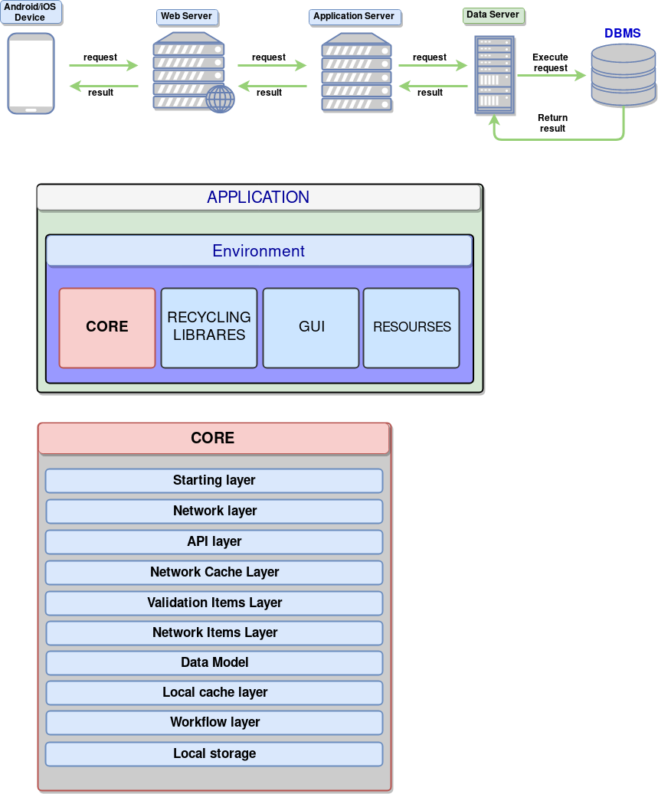

The advantages of this architecture, in our system are:

* Significant reduction of network traffic.
* Reduces the complexity of the client applications (most of the burden falls on the server side), and hence, reduced requirements for hardware facilities of the client machines.
* A special software tool - SQL-Server - leads to the fact that a substantial part of the design and programming tasks is already solved.
* Significantly increases the integrity and security of the database.
* A two-tier architecture is simpler, since all requests are serviced by the same server.

Structure of the mobile app

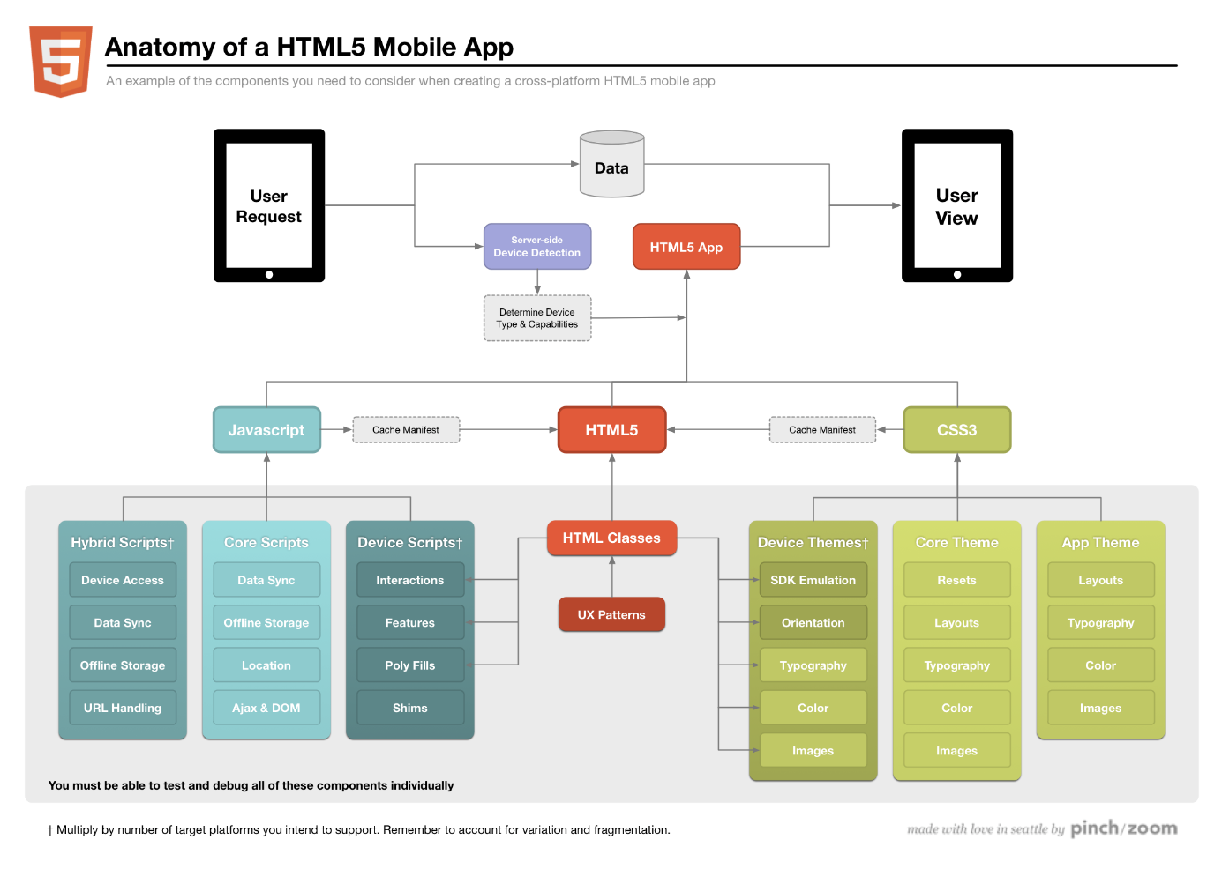

The core of the application includes the following:

Validation layer

Local cache layer

Core application

Workflow layer

Local storage

API layer

Data model

Network layer

Starting layer

1. Starting layer. Defining workflow, program execution begins.
2. Network layer. Provides the transport mechanism for interaction.
3. API layer. Providing a unified command system of interaction between client and server.
4. Validation Layer. Validation data, received from the network.
5. Data Model. The data model for the interconnection of data entities.
6. Local cache layer. Local caching layer that provides local access to network resources that are already received.
7. Workflow layer. Including classes and algorithms specific to the application.
8. Local storage.